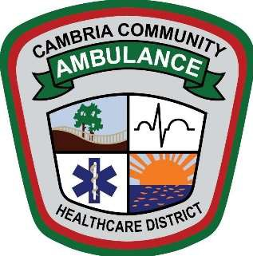

**CAMBRIA COMMUNITY HEALTHCARE DISTRICT**

**Property & Facilities Committee Meeting**

**March 20, 2025, 2:00 pm**

The regular meeting of the Cambria Community Healthcare District

will be held at the CCHD District Office, 2535 Main Street, Cambria, California.

Join Zoom Meeting  
<https://us02web.zoom.us/j/83165957131?pwd=fuZJFxmWjXqx7VxXZjllgmRGhIsXzU.1>

Meeting ID: 831 6595 7131 Passcode: 931571

# AGENDA

## OPENING

* 1. Call to order

## PUBLIC COMMENT FOR ITEMS NOT ON THE AGENDA

* 1. Members of the public wishing to address the Board on matters other than scheduled items may do so when recognized by the Board of Directors Committee Chairperson. Presentations are limited to a maximum of three minutes per person.

## CONSENT AGENDA

## New Ambulance Station – Update

## USDA Grant Requirements

## District Equipment Review

1. **ADJOURNMENT** 
   1. Next meeting date TBD

Copies of the monthly agenda, staff reports and written materials provided to the Committee may be obtained online at [www.cambria-healthcare.org](http://www.cambria-healthcare.org), and are also available at the District office located at 2511 Main Street, Cambria, during regular business hours. Any changes or additions to the agenda will be posted at the District office and on the District website.